Problem One
1.Program:
Design not include math.h(sine.c):
---------------------------------------------------------------------------------------------------------------------------------------------
#include<stdio.h>
#include<stdlib.h>
#define tim 20
int main(void)
{
short n;
double x;
printf("\n---------------∮This program is-★-B9502028-★-陳敬翔-create∮---------------\nThis program can calculate trigonometric: sin,\nPlease enter the angle : ");
scanf("%lf",&x);
x=x*3.1415926535897932384626433832795/180;
double part=x,sin=x;
for(n=1;n<=tim;n++)
{
part=part*(-1)*x*x/(2*n)/(2*n+1);
sin=sin+part;
printf("%.15lf\n",sin);
}
getch();
return 0;
}
---------------------------------------------------------------------------------------------------------------------------------------------
Use math.h create(math_sine.c):
---------------------------------------------------------------------------------------------------------------------------------------------
#include<stdio.h>
#include<stdlib.h>
#include<math.h>
int main(void)
{
printf("\n---------------∮This program is-★-B9502028-★-陳敬翔-create∮---------------\nThis program can calculate trigonometric: sin,\nPlease enter the angle : ");
double x;
scanf("%lf",&x);
x=x*4*atan(1)/180; /*pi=4*atan(1)*/
printf("%.15lf",sin(x));
getch();
return 0;
}
---------------------------------------------------------------------------------------------------------------------------------------------
I try to enter angle 0.5235*180/pi to those programs, these results both equal,
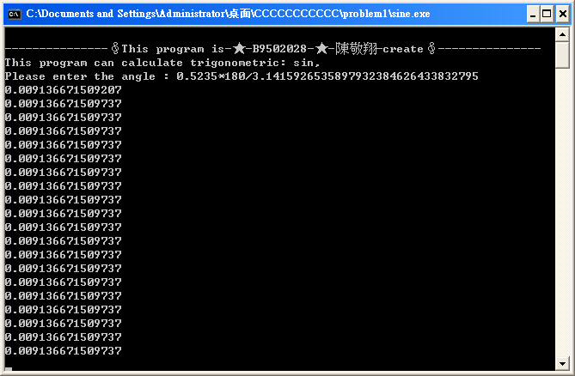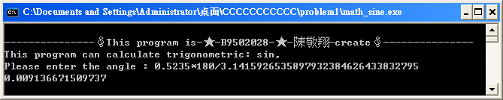
but when I change the ”sine.c” x’s data type to “float”,this result can not print:
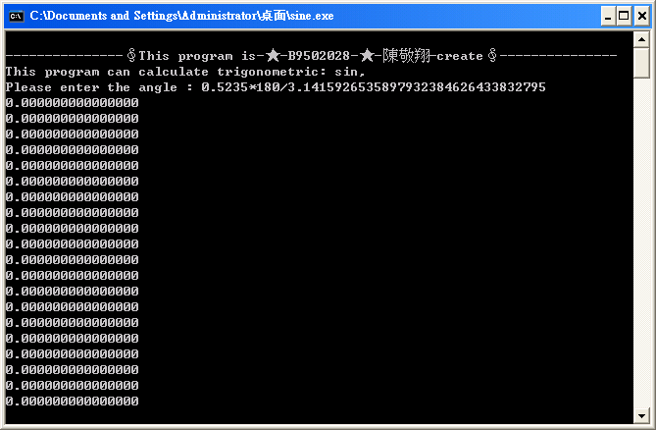
The reason is the x’sdata type can cot save so much decimal data, float range is 2.22E-308~1.7E+308, and double range is 3.3E-4932~1.18E4932, so that cause overflow.
And when I design this file, at first, I write this sine program(bad_sine.c):
---------------------------------------------------------------------------------------------------------------------------------------------
#include<stdio.h>
#include<stdlib.h>
#define tim 20
short sign(short sig)
{
if(sig%2==0)
{
return 1;
}
else
{
return -1;
}
}
double mult(double mul,short deg)
{
double mul_temp=1.0;
for(;deg>=1;deg--)
{
mul_temp=mul_temp*mul;
}
return mul_temp;
}
unsigned long step(unsigned long base)
{
if((base==0)||(base==1))
{
return 1;
}
else if(base<0)
{
return -1;
}
else
{
return base*step(base-1);
}
}
int main(void)
{
int n;
double x,sin;
printf("\n---------------∮This program is-★-B9502028-★-陳敬翔-create∮---------------\nThis program can calculate trigonometric: sin,\nPlease enter the angle : ");
scanf("%lf",&x);
x=x*3.1415926535897932384626433832795/180;
for(n=1;n<=tim;n++)
{
sin=sin+sign(n-1)*mult(x,2*n-1)/step(2*n-1);
printf("%.15lf\n",sin);
}
getch();
return 0;
}
---------------------------------------------------------------------------------------------------------------------------------------------
But to execute this bad_sine.c happen many error:
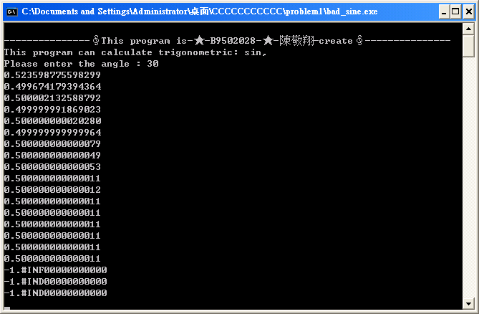
Then I try to solve this problem, at last, I found the important error is the function “step” overflow when it calculate n!, because n continuous raise until overflow, I change whole frame, let “part” in “sine.c” pass through each time calculate, can convergence, this way can not overflow!
Problem Two
Calculate 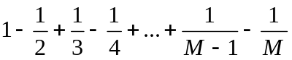,and use recursive(M_recursive.c):
---------------------------------------------------------------------------------------------------------------------------------------------
#include<stdio.h>
#include<stdlib.h>
double test(long m)
{
short sign;
if(m%2==0)
{
sign=-1;
}
else
{
sign=1;
}
if(m==1)
{
return 1;
}
else
{
return test(m-1)+(float)sign*1/m;
}
}
int main(void)
{
printf("\n---------------∮This program is-★-B9502028-★-陳敬翔-create∮---------------\nThis program can calculate 1-1/2+1/3-1/4+...+1/(M-1)-1/M\nPlease enter this M that is even : ");
long m;
scanf("%d",&m);
printf("%.15lf",test(m));
getch();
return 0;
}
---------------------------------------------------------------------------------------------------------------------------------------------
This file you can enter a number M, and calculate ,of course, the answer appear right away!
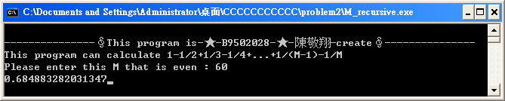
But if you input too hight number,overflow right away!
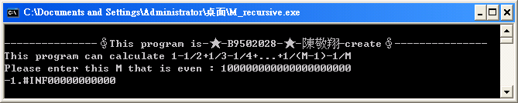
This file when you enter over 74454, it will unstable.
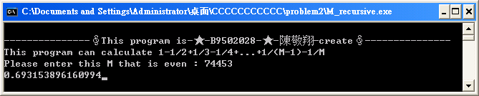
I found if you try to change “M” data type to “short”, entering over 98304, it will also unstable!
The computer is really a magical thing, can calculate so huge figure.
Problem Three
ascii.c:
---------------------------------------------------------------------------------------------------------------------------------------------
#include<stdio.h>
#include<stdlib.h>
int main(void)
{
FILE *write_file;
write_file=fopen("ascii.txt","wt");
if(write_file==NULL)
{
printf("File can not creat!");
getchar();
return 0;
}
short ascii;
printf("\n---------------∮This program is-★-B9502028-★-陳敬翔-create∮---------------\nThis program can print all ascii codes and write to \"ascii.txt\":\nPlease enter any key to continue!\n");
getch();
printf("\n ｜0 1 2 3 4 5 6 7 8 9 A B C D E F\n----------------------------------");
fprintf(write_file,"\n---------------∮This program is-★-B9502028-★-陳敬翔-create∮---------------\n ｜0 1 2 3 4 5 6 7 8 9 A B C D E F\n----------------------------------");
for(ascii=0;ascii<256;ascii++)
{
if(ascii%16==0)
{
printf("\n%x｜",(ascii/16));
fprintf(write_file,"\n%x｜",(ascii/16));
}
printf("%c ",ascii);
fprintf(write_file,"%c ",ascii);
}
printf("\n\nFile is already write to \"ascii.txt\"!!");
fclose(write_file);
getch();
return 0;
}
---------------------------------------------------------------------------------------------------------------------------------------------
This program can print all ASCII codes and write to file "ascii.txt", there is no too great problem.
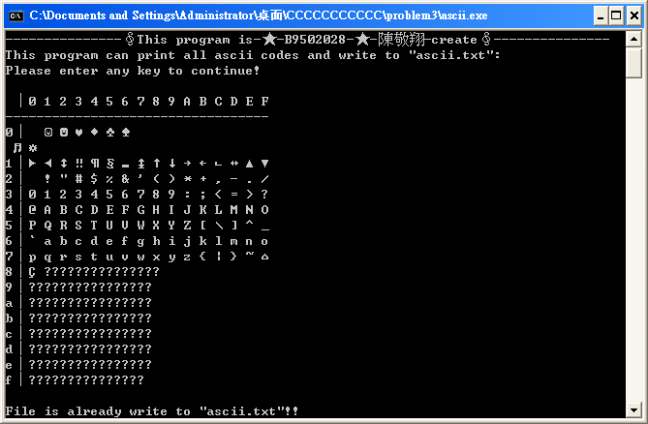
Here appear much “?”, because character code from 80H to FFH is not standard ASCII code. It IBM created, so can not normal show.
Problem Four
I write two program ,and compare mutual execution time(prime.c and bad_prime.c):
---------------------------------------------------------------------------------------------------------------------------------------------
#include <stdio.h>
#include <math.h>
#include<stdlib.h>
#include<time.h>
#define max 100000
int main(void)
{
printf("\n---------------∮This program is-★-B9502028-★-陳敬翔-create∮---------------\nThis program can print 1~%d prime number and calculate execute time,\nplease enter any key to start!",max);
getch();
printf("\n\n");
clock_t start, end;
start = clock(); /*calculate execute time*/
int prim_reg[max/2]={2,3,5,7},prim_elem=4;
int i,j,sqr,prim_deter,nex=5;
printf("%6d%6d%6d%6d",2,3,5,7);
for(i=11;i<=max;i+=2)
{
sqr=(int)sqrt((double)i);
for(prim_deter=0,j=1;prim_reg[j]<=sqr;j++)
{
if((i%prim_reg[j])==0)
{
prim_deter=1;
break;
}
}
if(prim_deter==0)
{
printf("%6d",prim_reg[prim_elem++]=i);
if(nex%13==0)
{
printf("\n");
}
nex++;
}
}
end = clock();
printf("\nThis program's execute time is %.14lf second",((end-start)/(double)CLK_TCK));
getch();
return 0;
}
---------------------------------------------------------------------------------------------------------------------------------------------
#include<stdio.h>
#include<stdlib.h>
#include<time.h>
#define max 10000
int main(void)
{
printf("\n---------------∮This program is-★-B9502028-★-陳敬翔-create∮---------------\nThis program can print 1~%d prime number and calculate execute time,\nplease enter any key to start!",max);
getch();
printf("\n\n");
clock_t start, end;
start = clock(); /*calculate execute time*/
short x;
int i,j,nex=1;
for(i=2;i<=max;i++)
{
x=0;
for(j=2;j<i;j++)
{
if(i%j==0)
{
x=1;
break;
}
}
if(x!=1)
{
printf("%6d",i);
if(nex%13==0)
{
printf("\n");
}
nex++;
}
}
end = clock();
printf("\nThis program's execute time is %.14lf second",((end-start)/(double)CLK_TCK));
getch();
return 0;
}
---------------------------------------------------------------------------------------------------------------------------------------------
First, let we compare their execution delay time by show 1~100000 prime number:
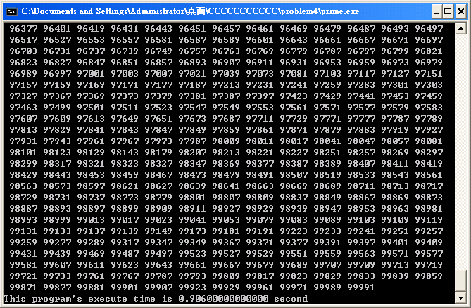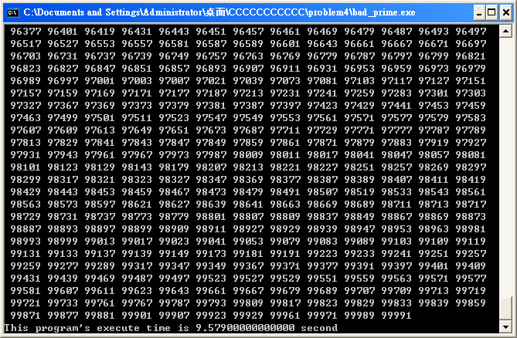
We find the first kind uses the way in which the radical narrows the number value range, the second kind is a way to look for slowly one by one directly, the postponement time of these two kinds of methods is lack of more than 10 times, therefore where to plant more practical!
Of course, we can change “#define max (value)”to use more time look for more prime number!!
The following is the maximum that my CPU run out
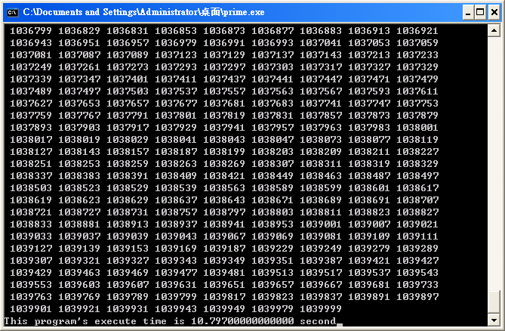
continuing add some number element will appear error…
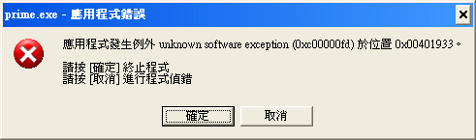
Problem Five
This program that keeps printing the multiples of the integer 2, I added some delay to convenient observe (multi.c):
---------------------------------------------------------------------------------------------------------------------------------------------
#include<stdio.h>
#include<stdlib.h>
#include<time.h>
int main(void)
{
printf("\n---------------∮This program is-★-B9502028-★-陳敬翔-create∮---------------\nThis program that keeps printing the multiples of the integer 2 :\n\n");
short x=2;
unsigned int delay;
long tem=1;
while(1)
{
printf("%10d",x*tem);
tem=tem*x;
for(delay=0;delay<=10000000;delay++)
{
;
}
}
getch();
return 0;
}
---------------------------------------------------------------------------------------------------------------------------------------------
We can look at the result, it told us it already overflow!
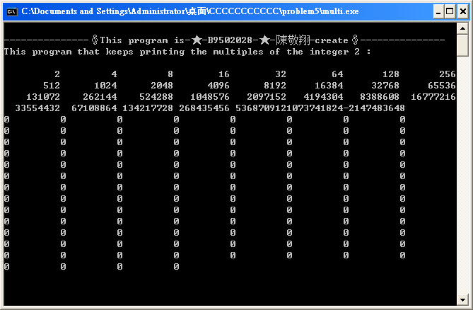
At first, it is normal as normal program, but after a while, it break…We know the program’s variable can not show too big number. Because this data type range had limit itself, it produced the wrong result directly!

